Online Quiz Application

.NET TECHNOLOGY (01CE0523)

MINI PROJECT REPORT

Submitted by:

Enrollment  92301703099  92301703066 | Student Name  Pinak Mer  Neal Pujara

BACHELOR OF TECHNOLOGY
in

Computer Engineering



Marwadi University, Rajkot

November, 2025

.NET Technologies (01CE0523)
Mini Project
Faculty of Technology, Marwadi University
Computer Engineering Department
2025-26

CERTIFICATE

This is to certify that the project report submitted along with the project entitled
Online Quiz Application has been carried out by Pinak Mer(92301703099) and
Neal Pujara (92301703066) under my guidance in partial fulfillment for the degree of Bachelor of Technology in Computer Engineering, 5th Semester of Marwadi University, Rajkot during the academic year 2025-26.

Sign: Sign:

Prof. Chetankumar Chudasama Dr. Krunal Vaghela

Internal Guide Head of the Department

Index
Acknowledgments i
Abstract ii
- Introduction 1
- Technology used and Implementation Strategy 4
- Implementation Snapshot 16
- Conclusion 28
References 30

Acknowledgments

This mini project would not have been possible without the Guidance and the help of several Individuals who in some ways contributed their valuable time and assistance in the completion of this Internship.

We would like to thank our college Marwadi University for giving us this opportunity of doing Internship and gaining Industry Level Experience in the field that we are interested in. Our sincere gratitude to our Head of The Department (HOD), Dr. Krunal Vaghela, our Internal Guide, Prof. Chetankumar Chudasama for helping and solving our queries whenever required.

Abstract

FunQuest is a premium-grade, interactive quiz application designed to deliver a seamless and engaging experience for users across educational and entertainment domains. Developed using ASP.NET Core and MongoDB, the platform combines robust backend architecture with a visually refined frontend, offering features such as user authentication, quiz hosting, dynamic question rendering, and real-time result evaluation.

The project emphasizes clarity, responsiveness, and aesthetic excellence, incorporating session-based user tracking, randomized participant naming, and detailed result feedback. With a modular structure and scalable design, FunQuest serves as a model for modern web-based quiz systems that prioritize both functionality and user delight.

This report outlines the conceptual foundation, technological stack, implementation strategy, and visual snapshots of FunQuest, culminating in a comprehensive analysis of its performance and future potential.

Introduction

In today’s digital landscape, interactive learning and entertainment platforms have become increasingly popular. FunQuest is a modern web-based quiz application designed to combine educational value with engaging user experience. The project was initiated with the goal of creating a sleek, responsive, and feature-rich quiz system that could serve both casual users and academic environments.

FunQuest allows users to host quizzes, join sessions with randomized fun nicknames, answer multiple-choice questions, and receive instant feedback on their performance. The platform emphasizes clarity, usability, and aesthetic refinement, making it suitable for classrooms, training programs, and recreational use.

This report presents a comprehensive overview of FunQuest’s development journey — from conceptualization to deployment. It outlines the technologies used, the implementation strategy adopted, and the design decisions that shaped the final product. Through this, the report aims to highlight how thoughtful architecture and polished UI can elevate a simple quiz app into a premium-grade experience.

Technology used and Implementation Strategy

Layer | Technology | Purpose
Backend | ASP.NET Core MVC | Handles routing, controllers, session management, and business logic
Database | MongoDB | Stores quizzes, participants, and responses in a flexible NoSQL format
Frontend | Razor Views + CSS | Renders dynamic pages with elegant styling and responsive layout
Session | ASP.NET Session State | Tracks user identity and quiz progress across pages
Hosting | HTTP via Kestrel | Local development and testing using dotnet run with HTTP profile

Implementation Strategy

- Modular Architecture
  - Separated concerns into Models, Views, Controllers, and Services
  - Used MongoDbService for clean database access

- User Flow Design
  - Login/Register → Choose Mode → Host/Join Quiz → Play → Submit → Result
  - Session variables track Username, QuizCode, and ParticipantName

- Quiz Hosting Logic
  - Host generates a unique 6-character code
  - Quiz saved to MongoDB with questions and title

- Participant Join Logic
  - User enters code and name
  - System stores participant with score initialized to 0

- Play Quiz Experience
  - Questions rendered dynamically
  - Options clickable with instant visual feedback
  - Answers stored via hidden inputs

- Submission and Scoring
  - Each correct answer adds 100 points
  - Score saved to participant record
  - Result page shows detailed feedback per question

- Styling and UX
- Premium dark theme with gradients and glass effects
- Responsive layout for desktop and mobile
- Clear visual cues for selected options and result status

Implementation Snapshot

This shows login page.
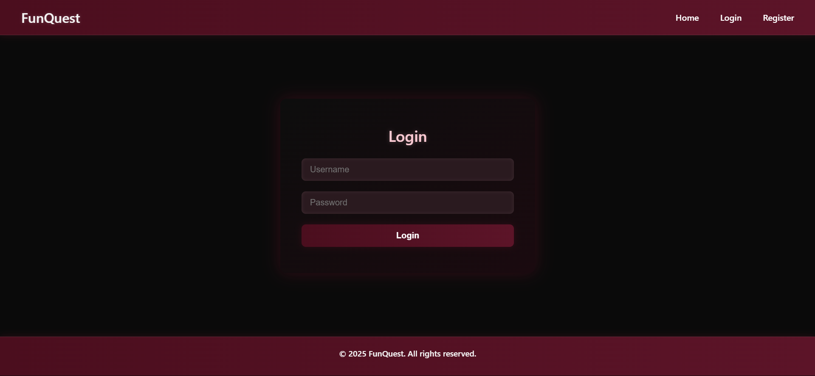

This show register page.
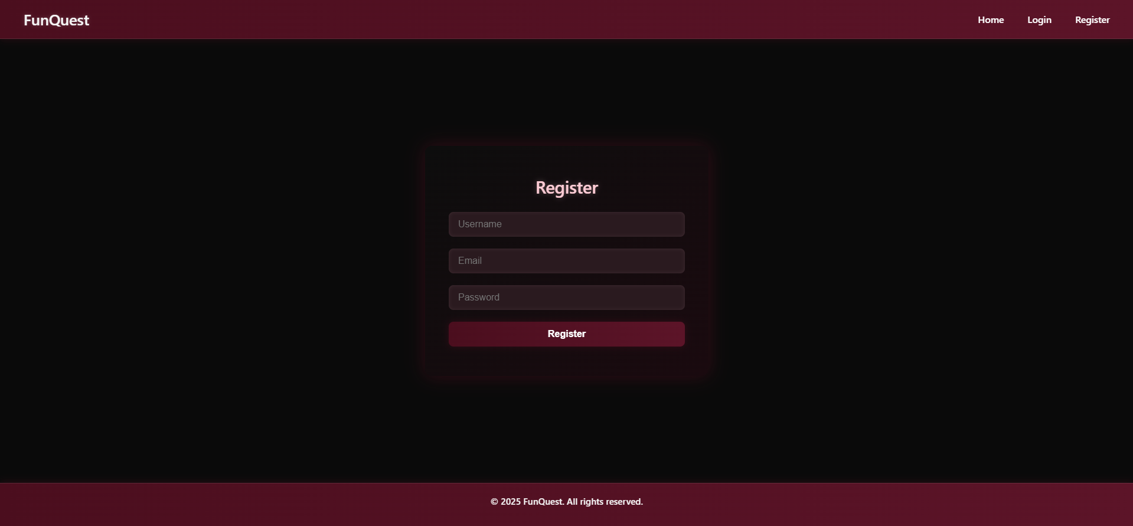

In this you can create your own quiz means you are host.
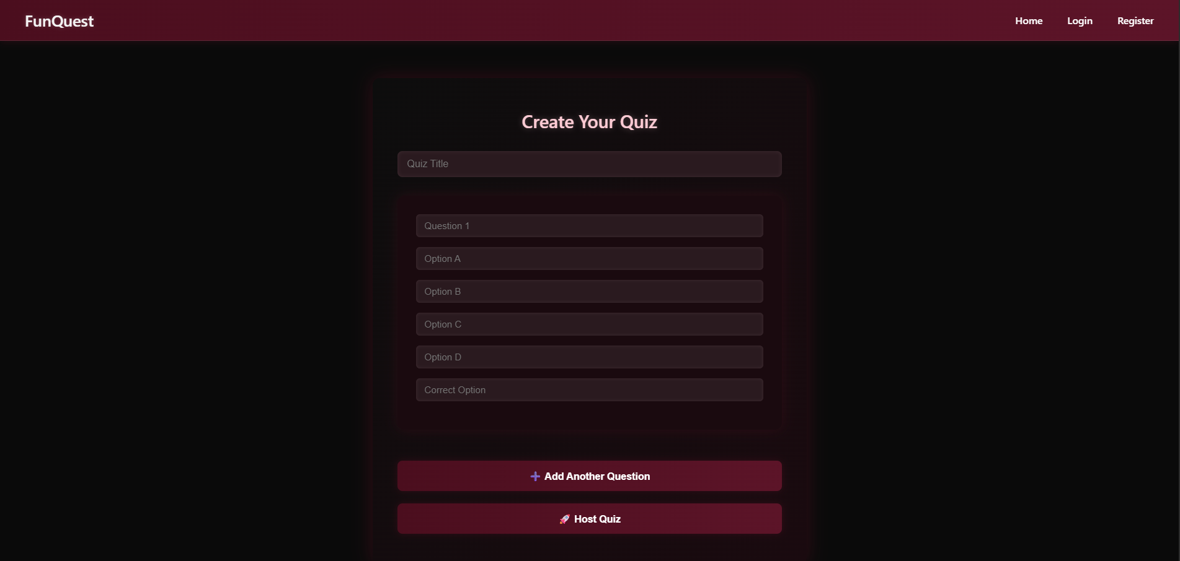

In this you can join the quiz as a player.
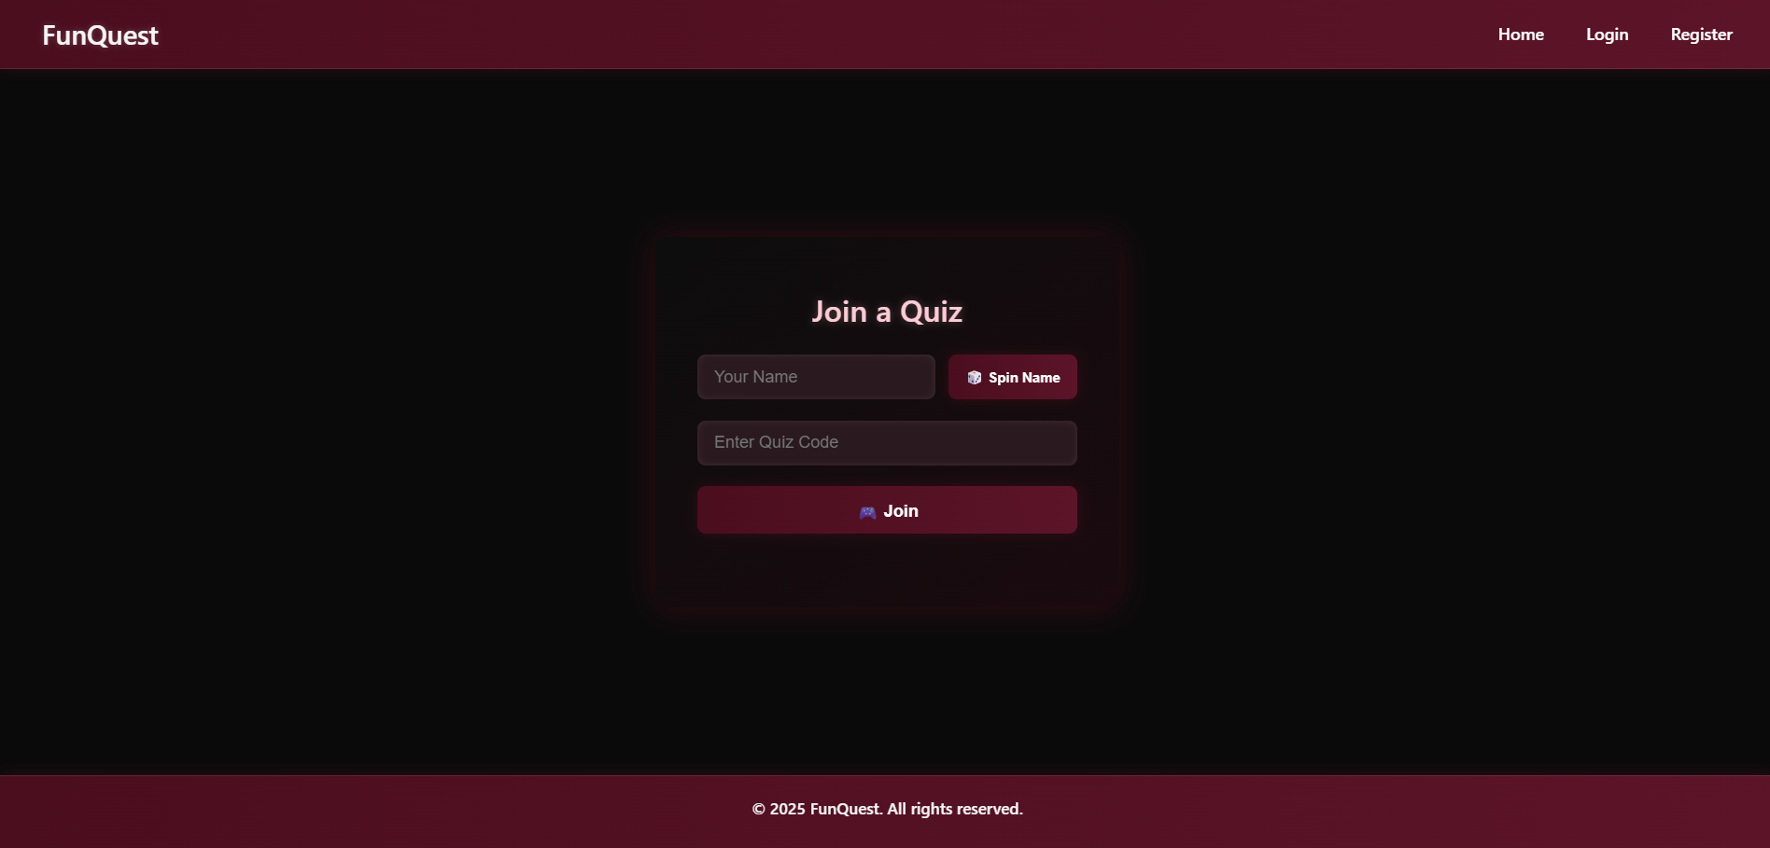

This page shows your quiz question when you start the quiz.
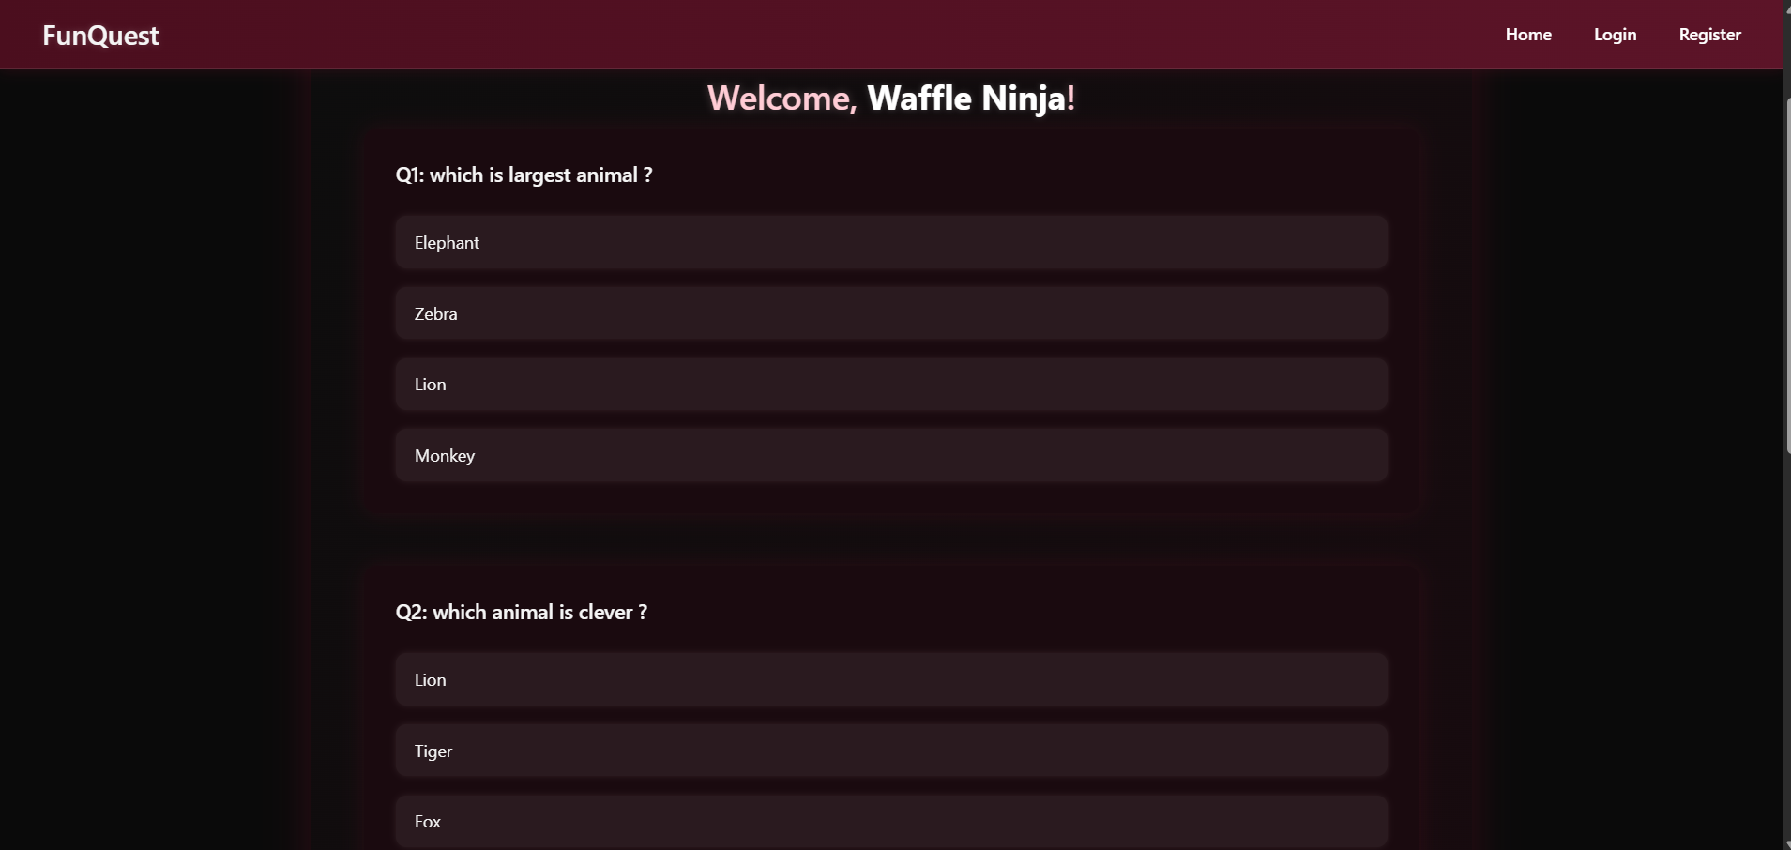

This page shows the result of your quiz which is given by you.
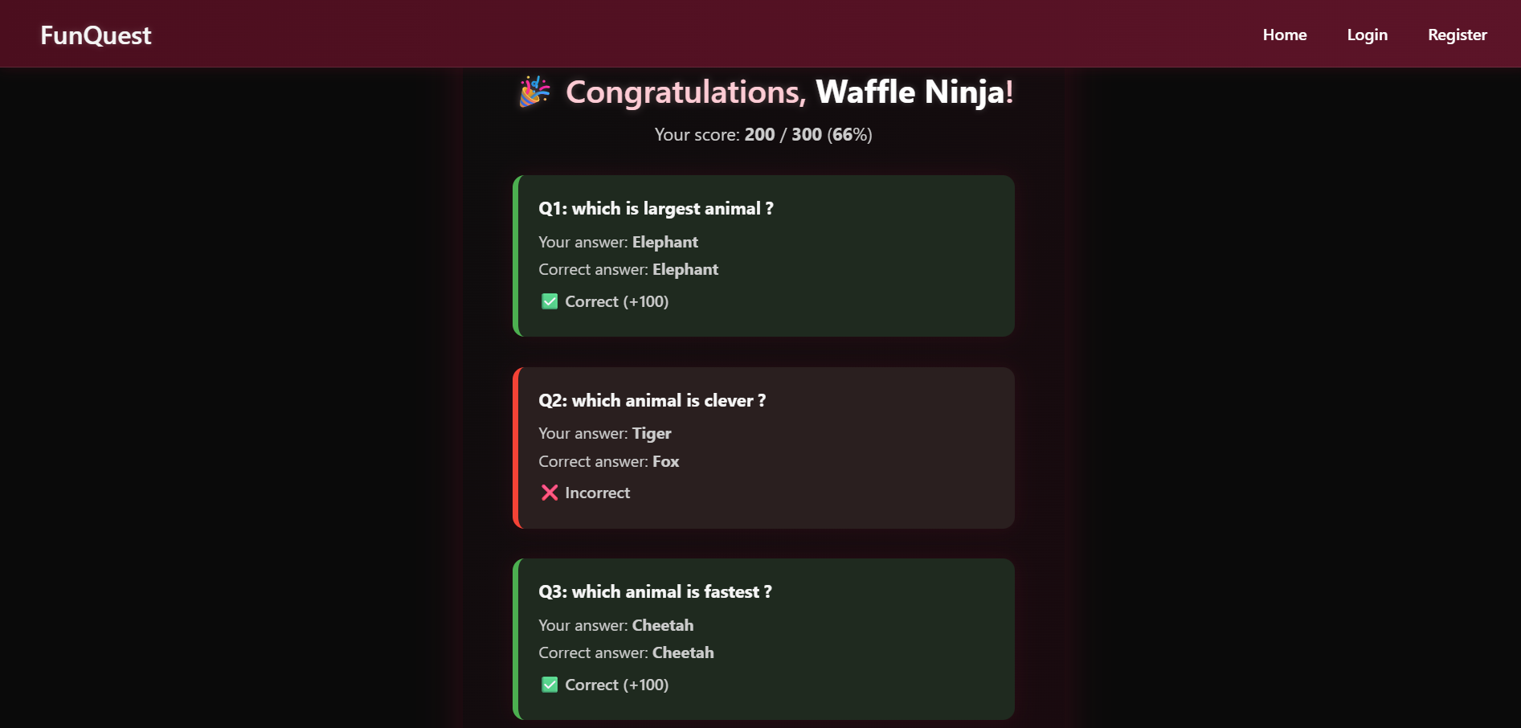

4. Conclusion

FunQuest represents a successful fusion of technical precision and user-centric design. From its modular architecture to its elegant interface, the application demonstrates how thoughtful implementation can transform a simple quiz system into a premium-grade experience. By leveraging ASP.NET Core for backend logic and MongoDB for flexible data storage, the project achieves both scalability and maintainability.

The interactive flow from hosting and joining quizzes to playing and reviewing results is streamlined through session management and dynamic rendering. The result feedback system, which highlights correct and incorrect answers with visual cues, adds depth and clarity to the user experience.

Beyond its technical merits, FunQuest showcases the importance of aesthetic refinement in modern web applications. The use of gradients, glass effects, and responsive layouts elevates the platform’s appeal and usability. As a whole, the project stands as a testament to the power of incremental design, collaborative iteration, and a clear vision for excellence.

Future enhancements may include leaderboard integration, timed quizzes, and multiplayer support all of which can build upon the solid foundation already in place.

References

- Microsoft Docs - ASP.NET Core MVC
https://learn.microsoft.com/en-us/aspnet/core/mvc

- MongoDB Documentation - NoSQL Database
https://www.mongodb.com/docs

- Razor Pages Syntax Guide
https://learn.microsoft.com/en-us/aspnet/core/razor-pages

- CSS Styling and Flexbox Layout
https://developer.mozilla.org/en-US/docs/Web/CSS

- Visual Studio IDE - Project Development
https://visualstudio.microsoft.com

- Stack Overflow - Community Support and Debugging
https://stackoverflow.com

- Font and UI Inspiration - Google Fonts & UI Patterns
https://fonts.google.com
https://www.uipatterns.com

